**Seed Storage Guidelines and Sample Testing Submission**

At the conclusion of planting each season, growers and agricultural retailers may find they have some seed remaining which may be kept for use the following season. Unfortunately, ongoing seed quality cannot be guaranteed, however, in order to give it the best chance of maintaining quality, there are a few recommended guidelines to keep in mind:

* Seed is a living organism. In order to stay this way, it must be looked after;
* Keep out of the weather or being exposed to harsh conditions.
* Sunlight, high temperatures, high humidity and rainfall can reduce seed quality and lead to bags perishing;
* Keep seed away from rodents such as mice. Storing seed with bait is a good idea;
* Regularly monitor and keep insect free;
* Do not fumigate with methyl bromide for insect control as this will dramatically reduce seed germination;
* Do not store seed on the western walls of sheds, near shed rooves (top of pallet racking) or
* Do not store close to doorways and direct sunlight;
* Store in areas which provide access to all sides so pest activity can be easily monitored.

To assist with determining seed quality of any carry over Pacific Seeds brand products, Advanta Seeds offers a free germination testing service to both growers and agricultural retailers. If you have any Pacific Seeds stock you wish to test in preparation for planting, please feel free to use the form and directions on the following page to submit a sample (or samples) for testing. Samples should be sent at least one month before the start of the planting season.

For more information, please contact your local Pacific Seeds Territory Manager.

***Example of damage to a seed bag.***

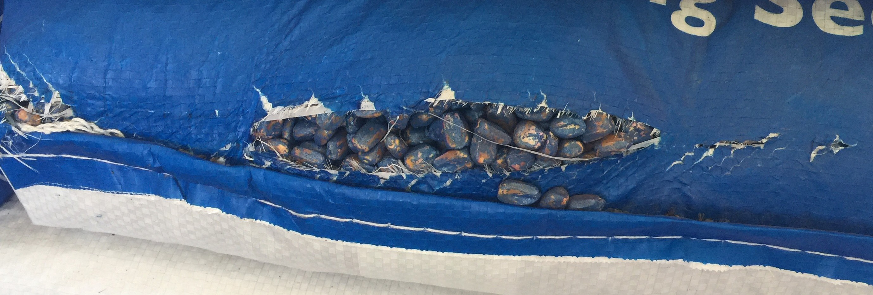

 

**Canola Seed Storage Information and Recommendations**

* Storage Temperature
* Seed Moisture Content
* Seed Oil Content
* Relative Humidity
* Storage Time
* Position of seed near heated walls or surfaces
* Condition of the seed Packaging
* Storage dampness and vermin levels
* Airflow and cooling or ventilation

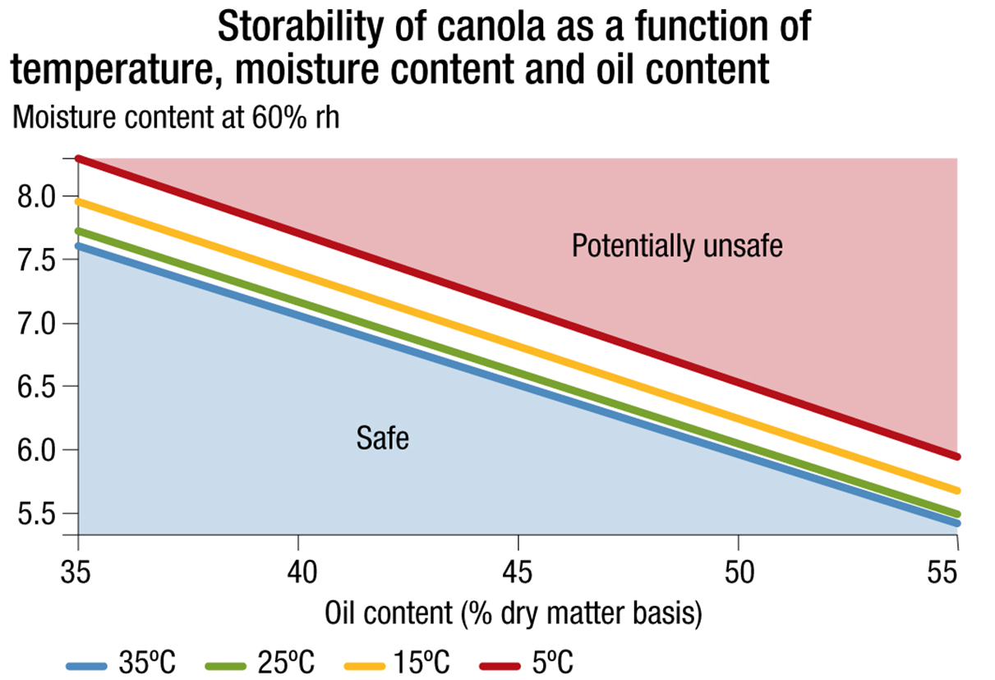

**SAMPLE SUBMISSION FORM FOR GERMINATION TESTING**

# Submitter: Home Phone:

**Address: Mobile:**

**Date:**

# Email:

Results will be emailed to the address provided above

|  |  |  |  |  |
| --- | --- | --- | --- | --- |
| Variety | Batch Number | No. of Bags | Sample No (QC USE ONLY) | Comments |
|  |  |  |  |  |
|  |  |  |  |  |
|  |  |  |  |  |

Please send clearly marked samples to:

# QUALITY CONTROL LABORATORY PACIFIC SEEDS

**PO BOX 337**

**268 Anzac Ave**

**TOOWOOMBA QLD 4350**

Directions for sampling

1. Ensure representative samples are taken for each batch of seed you have on hand
2. Use an individual sample bag for samples from each batch number
3. Mark each sample bag with date, grower name, variety name and batch number
4. Complete form above and post with sample/s to address on left

The information provided in this publication is intended as a guide only. Advanta Seeds Pty Ltd (including its officers, employees, contractors and agents) (‘Advanta Seeds’) can not guarantee that every statement is without flaw of any kind. While Advanta Seeds has taken all due care to ensure that the information provided is accurate at the time of publication, various factors, including planting times and environmental conditions may alter the characteristics and performance from plants.

Advanta Seeds shall not be liable for any errors or omissions in the information or for any loss, injury, damage or other consequence whatsoever that you or any person might incur as a result of your use of or reliance upon the products (whether Advanta Seeds products or otherwise) and information which appear in this publication. To the maximum extent permitted by law, the liability of Advanta Seeds for any claim whatsoever arising out of the supply or use of or reliance upon the products and information in this publication (including liability for breach of any condition or warranty implied by the Trade Practices Act 1974 or any other law) is limited at its discretion, to the replacement of the products, the supply of equivalent products or the resupply of the publication. For application to specific conditions, seek further advice from a local professional. © Advanta Seeds 2017